Data Analysis on Electric Vehicle

Download the dataset - CLICK HERE

Task 1: This is an open ended problem. Apply Exploratory Data Analysis (Univariate and Bivariate) on the dataset available above.

Task 2: Create a Choropleth using plotly.express to display the number of EV vehicles based on location.

Click here for the Plotly tutorial.

Note: Following is an example of a Choropleth animation. It might take a couple of minutes to render.
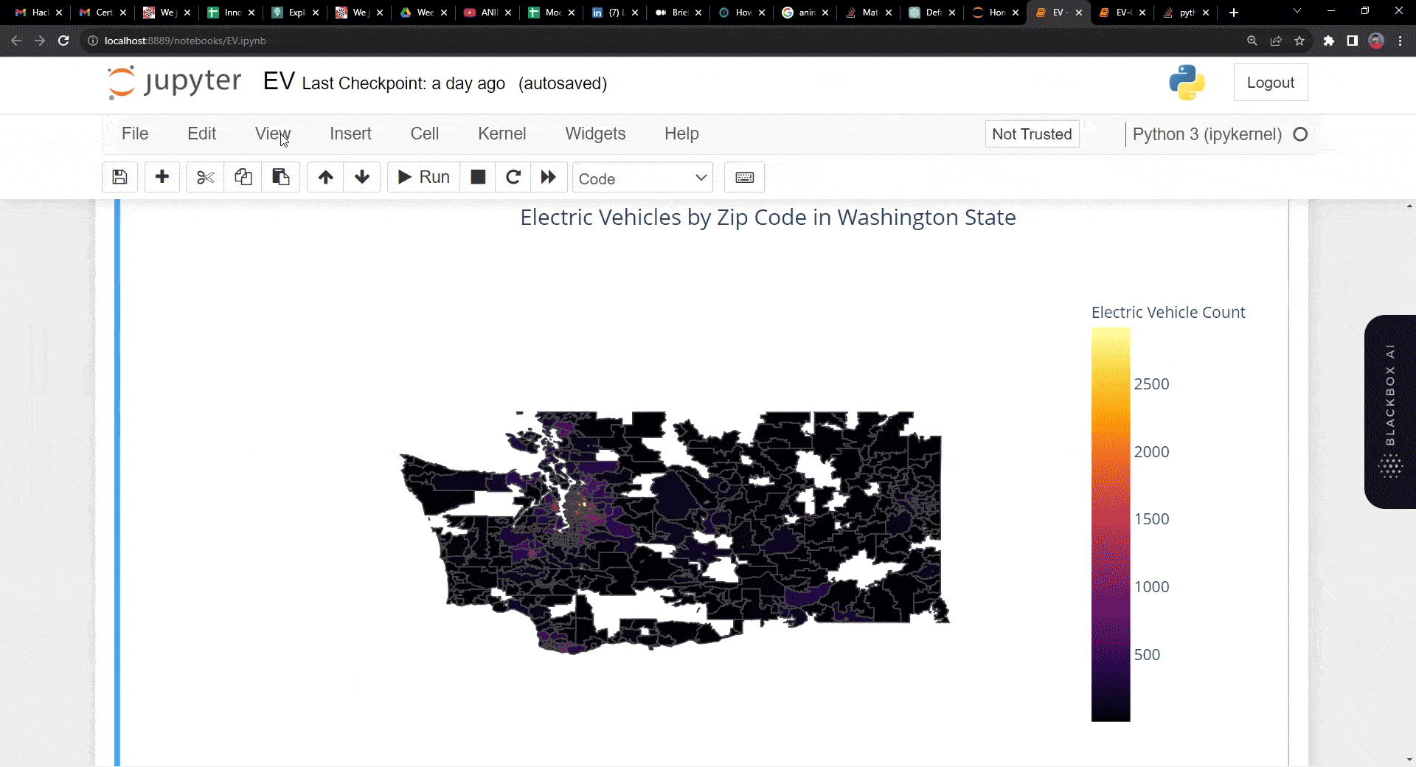

Task 3: Create a Racing Bar Plot to display the animation of EV Make and its count each year.

Click here for the Racing Bar Plot Tutorial.

Note: Following is an example of a Racing Bar Plot animation. It might take a couple of minutes to render.

Task 4: Write a Linkedin Post which reflects your work and experience for this project. Don’t forget to tag Innomatics Research Labs in your posts.

